**Algebra Questions**

**Figure This**

Ben has a box with a number in it that is greater than 7.  
Moana has a box with a number in it that is less than 9.  
Tom has a box with a number in it that is greater than 5.

They all have the same number. What is it?

Teaching sequence

1. Introduce the problem by asking a group of 3 children to stand at the front of the class. Next to them stand a group of 4 children.
2. Ask the children to think of ways to describe what you have done using the symbols you have written on the board (3, 4, 7, = <, >, 1 ).  
   Eg 3 + 4 = 7, 7 – 4 = 3, 3 < 4
3. Record the sentences, discussing the use of the symbols.
4. Pose the problem.
5. As the children work on the problem ask questions that focus on the use of the inequalities.  
   *Could you write a statement for the first clue?*
6. Share solutions.

Extension to the problem  
Make up your own 3 clue problems for others to solve.

Solution  
A nice way to do this problem is to use a drawing. We can represent each of the numbers in the children’s boxes by a line. The line has regular numbers on.  We have drawn arrows where the possible numbers are.

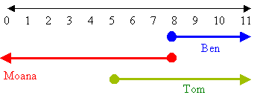

**Taxi Fare**

Problem 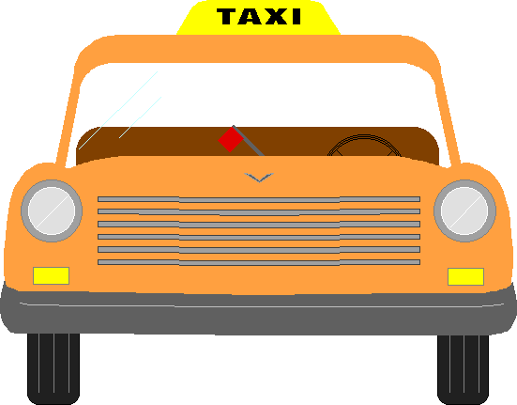  
In Beltenup, taxi drivers charge £1 flag fall once you get in the car. Then they charge you £2 for each kilometre you travel. How far can you go if you and your friends have just £23 between you?

Teaching sequence

1. Set the scene for the problem with a discussion about taxis. More specifically check that the children understand how taxis charge – flagfall and £ per km.  
   Tell the children about the rates of "Beltenup" taxis.   
   Ask: *If you want to travel 4 km how much would it cost?*
2. Discuss solutions.
3. Pose problem for the children to work on in pairs.
4. As the children work ask questions that focus their thinking on the repeating pattern of twos.  
   *What are you using to solve this problem? How is that helping you?  
   What numbers are you using? Why?  
   What is the next number? How do you know?*
5. Share solutions.
6. Conclude with some class practice counting forwards and backwards in twos using different starting numbers.

Extension to the problem  
How far could I travel in a Beltneup taxi if I had £40?

Solution  
There are lots of ways of doing this. Let’s use a table.

|  |  |  |  |  |  |  |  |  |  |  |  |  |
| --- | --- | --- | --- | --- | --- | --- | --- | --- | --- | --- | --- | --- |
| $ | 1 | 3 | 5 | 7 | 9 | 11 | 13 | 15 | 17 | 19 | 21 | 23 |
| km | 0 | 1 | 2 | 3 | 4 | 5 | 6 | 7 | 8 | 9 | 10 | 11 |

So the friends can travel for 11 km in the taxi.

**Extension**: 19.5 km

**The Workers**

**Problem**  
Can you match the night nurse, a taxi driver and a teacher to their graphs?

Teaching sequence

1. Draw the axis of a graph on the board. Ask: *what can you tell me about this?*
2. Add title of graph (distance from home) and axis labels (time, distance in km)  
   *Now what can you tell me about the graph?*
3. Plot a point on the graph.  
   *What does this mean?*
4. Plot another point and join the two points with a line.  
   *What does this mean?*
5. Pose the problem.
6. As the children work ask them to describe the story in each of the graphs.
7. Share solutions.

Extension to the problem  
Draw your own distance from home graph for a school day.

Solution  
The night nurse should be easy to pick out because she is furthest away from her home during the night.  So the second graph is the night nurse.

The teacher stays at school during the day so hers is the first graph.   The taxi drivers distance from home would always be changing as he drives around the city so his is the third graph.

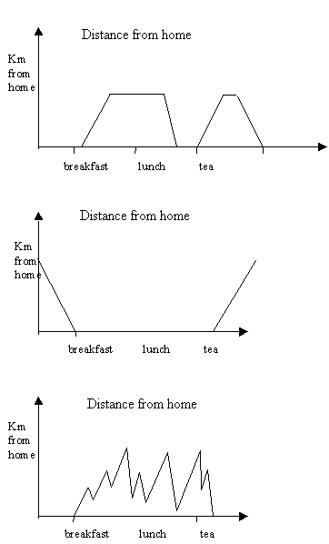

**How old?**

**The problem**  
There is a family with four children. Between each child there is an age difference of 2 years. The oldest child, Maryanne is less than 11 years old. The youngest child, Tom, is older than 5. In between Maryanne and Tom are the twins – Claudia and Cassie. What is the age of each child in this family?

Teaching Sequence

1. Display the 4 pictures – ask the children to make statements that could be true using the pictures.
2. Ask the children to make statements about the pictures using the >, < symbols.
3. Read the problem to the class.
4. Discuss the words older, younger and twins.
5. Brainstorm for ways to solve the problem.
6. As the students work on the problem, ask them to explain their thinking using the <, > symbols. (unless you sepcfically ask the children to use the symbols we believe its liley that they won't use them in the solution). Ask them to explain how they know which symbol to use.
7. Encourage the children to use the symbols in their record of the solution.
8. Share the solutions.

Solution  
If the oldest child is less than 11 and the youngest child is more than 5, the ages of the children will be between 5 and 11. So write all the numbers between 5 and 11, that is 6, 7, 8, 9, 10.  
As there is a difference of 2 years between each year of birth, the ages must be 6, 8 and 10.  
So Maryanne’s age = 10 (check 10 < 11); and Tom’s age = 6 (check 6 > 5); and Claudia’s age = 8 (check 10 – 2 = 8 and/or 6 + 2 = 8); and Cassie’s age = 8 (check 8 = 8).

**Treasure to Ship**

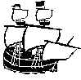**Problem**  
There are 2 pirates and 4 treasure chests on an island. The pirates have 1 small boat to take the treasure to their ship. The boat can take 2 pirates or 1 pirate and 1 chest of treasure.

How many trips do the pirates have to take to get all the treasure and both pirates onto the ship?

Note: The ship needs 2 pirates to sail it. Don't worry about one pirate sailing off with all the treasure!

Teaching Sequence

1. Introduce the problem by reading a poem about pirates
2. Pose the problem to the class.
3. Ask the children to describe the problem in their own words to make sure that they understand what is required.
4. Using 2 children act out a trip to the ship with the treasure. Discuss the ways that you could keep track of the trips taken (draw, list)
5. Let the children continue the problem in pairs.
6. As the children work ask questions that focus their thinking on the steps they are taking. *How many trips have you taken?  
   How did you work out who to put in the boat?  
   Can you see any patterns in what you are doing? Describe them.  
   How are you keeping a record of the strips?  
   Do you think that you can use a smaller number of trips?*
7. Share the written solutions to the problem.

Extension  
What if there are 8 treasure chests?

Solution  
There are 9 trips from island to ship.

1. 2 pirates go to ship
2. 1 pirate returns for treasure
3. Pirate takes 1 treasure chest to ship
4. Returns to island
5. Takes 2nd treasure chest to ship
6. Returns to island
7. Takes 3rd treasure chest to ship
8. Returns to island
9. Takes last treasure chest to ship

Note that steps 1 and 2 can occur at any time that the small boat is on the land or steps 3 to 9 can be followed by ‘returns to land, 2 pirates go to ship’.

**Extension:** each treasure chest requires two trips, one to the ship and one back to the land. So with 8 chests the pirates will need 8 x 2 trips with the chests and 1 trip to take the extra pirate. This means 17 trips.

(With c chests and two pirates there will need to be 2c + 1 trips.)

**Cannon Balls**

**Problem  
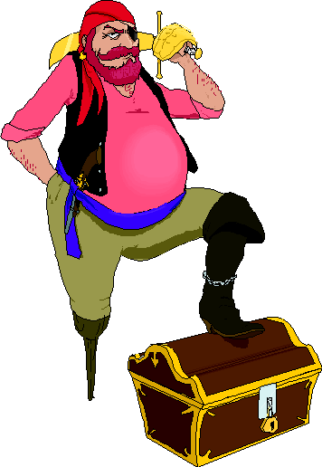**There is a pyramid of cannon balls on a pirate ship. The first layer looks like this.****  
  
How many cannon balls are there in the first layer?  
How many cannon balls will there be in the second layer?  
How many cannon balls will there be in the third layer?  
How many cannon balls in the top layer?  
How many cannon balls do you need to complete the pyramid?

Teaching Sequence

1. Introduce the problem using a number of cannonballs (tennis balls or similar). Ask the children to think of ways that they couild stack the balls.
2. Read problem. Check that the children understand the meaning of the word 'layers' and also know how the pirates piled up their cannon balls.
3. Ask the children to guess how many cannonballs they will need. Record the estimates to check against later.
4. Brainstorm for ways to solve the problem. (Link these to problems that they have solved before.)  
   *What strategies could you use?  
   What equipment will you need?  
   How will you record your information?  
   What do you have to find out?*
5. As the children work ask questions that focus on the patterns they are using to solve the problem. *What can you tell me about the cannonballs?  
   How are you keeping track of the number of cannonballs?*
6. Share solutions

Other contexts  
Sometimes fruit is piled this way at supermarkets.

Extensions  
If the pirates wanted to put another layer of cannon balls on their pile they would need to lift it up and put another triangle on the bottom. How many cannon balls would there be in such a layer?

Solutions  
In the first layer there are 1 (across the top) + 2 and 3 (across the middle two rows) + 4 (four at the bottom) = 10 cannon balls.

In the second layer there are 1 + 2 + 3 = 6 cannon balls.

In the third layer there are 1 + 2 = 3 cannon balls.

There is only one cannon ball in the top layer.

All together there are 10 + 6 + 3 + 1 = 20 cannon balls.

Extension:   
If a layer of cannon balls is put underneath the present bottom one it would need 1 + 2 + 3 + 4 + 5 = 15 cannonballs.

**Jo’s Table**

**Problem**  
Jo has some squared paper handy. She put the even numbers from 2 to 12 along the top and the numbers 3, 6, 9, 12, 15, 18 down the side. She then started adding the numbers together. As she filled in the numbers she began to see patterns.

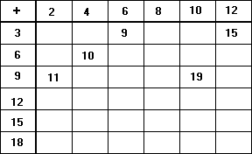

Find some patterns for yourself. Use them to complete Jo’s table.

Teaching sequence

1. Introduce the problem to the class. Ask them  
   *What number do you think goes here?  
   And what about here?*Put these numbers onto the table.
2. Let the children work on the problem with a partner. Check that they understand what they are supposed to be doing.
3. As a whole class share the children’s solutions. Make sure that they are looking for patterns along the diagonals. Ask them to say why their pattern works.
4. Encourage them to go on to try the Extension problem.
5. Discuss the answers that the children get in a class situation. Ask them why their answers work. Possibly ask them to make up questions of their own.

Solution to the problem  
Jo’s completed table is shown below.

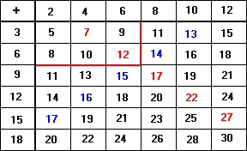

There are a large number of patterns that can be found here. The horizontal patterns are even and odd numbers. These occur because Jo is adding even numbers together or even numbers plus an odd number. Diagonal patterns such as the one in red, go up in 5s. This is because the horizontal numbers are increasing in 2s and the vertical numbers in 3s. Back diagonals (such as the one in blue) only increase in 1s. This is because there is an increase of 3 downwards but a decrease of 2 to the left. 3 – 2 = 1. Encourage the class especially to look for patterns that occur in the diagonals.